Temasek Polytechnic

School of Informatics & IT

Diploma in Game Design and Development

{TTSH/NCID : Infectious Disease} Technical Report

Project Particulars

|  |  |
| --- | --- |
| Supervisor | Malcom Grant |
| MP Project Title | Origin Of Infection |

Project Team’s Particulars

|  |  |
| --- | --- |
| Admission Number | Student Name |
| 2000384D | Yeo En Yew, Benjamin |
| 2000365C | Teo Yi Kai |
| 2000411E | Yap Wai Kit Perry |
|  |  |
|  |  |
|  |  |

Contents

Components Design

Components

Game Objects

Game Flow

Flow Chart Diagram

Development information

Library

Version of software

Hardware requirement

Setup of development platform

Detailed instruction on how to setup the development platform.

# Components Design

## Components

|  |  |
| --- | --- |
| *Component Name* | Talking |
| *Description* | *Allows the player to talk to the npc by having a UI appear for the player where a text box appear for what the npc is saying to the player with the npc name above this text box and buttons with different dialogue choices to talk to the npc* |
| *Variable* | Local NPCName - get the name of which NPC the player is talking to  Local npcText - Get text for the NPC UI  Local NPCDialogue - Get the dialogue for what the text should display  Local Options - Get options for the character dialogue  Local CloseButton - Get the final option to end the conversation |
| *Function* | *animatetext() - Displays NPC dialogue 1 letter at a time instead of all at once.*  *chooseOption1() - Returns NPC response to player choosing the first option*  *ChooseOption2() - Returns NPC response to player choosing the second option*  *ChooseOption3() - Returns NPC response to player choosing the third option* |
| *Game Object attached to* | NPCs’ GUI |
| *Author* | *Yeo En Yew, Benjamin* |

|  |  |
| --- | --- |
| *Component Name* | Emote |
| *Description* | *It makes the player do an action depending on the action this component is meant to play.* |
| *Variable* | local emote - This is to get the Animation the player is meant to do when this component is use. |
| *Function* | script.Parent.MouseButton1Click:connect(function() - To check if the player click the emote button and to play the Animation or stop it |
| *Game Object attached to* | Emote UI depending on which Animation the player is meant to do. |
| *Author* | *Yeo En Yew, Benjamin* |

|  |  |
| --- | --- |
| *Component Name* | MenuScript |
| *Description* | *Controls the menu with the 3 game mode options for the player to choose and the camera switching from the menu view to the player view while also control the other scripts on which script should activate for the gamemode.* |
| *Variable* | Local CurrentCamera - Use to get the camera of the player  _G.GameStart - Use to tell the other scripts whether the player has started playing the game. |
| *Function* | *animatetext() - Displays Story 1 letter at a time instead of all at once.*  *Story() - Displays the story for the player*  *PlayMode() - Change the player’s view and position from the menu to the map while also load all the right data of the player if any.*  *FreeMode() - Change the player’s view and position from the menu to the museum.*  *GuideMode() - Change the player’s view to another camera and start the tour for the player.* |
| *Game Object attached to* | Menu |
| *Author* | *Yeo En Yew, Benjamin* |

|  |  |
| --- | --- |
| *Component Name* | Sample |
| *Description* | *To control the testing chamber which activates phase 2 for the player by indicating how many samples the player has gotten that are infected with the unknown virus and how many left the player has to obtain to continue to phase 2/story.* |
| *Variable* | Local TestingChambers – Use to check if the player has interacted with the testing chamber  _G.InitialTest - Use to indicate how many correct infected samples are already in the machine |
| *Function* | *animatetext() - Displays Story 1 letter at a time instead of all at once.*  TestingChambers.Triggered:Connect(function() - Add in the samples the player collected and check if the player has any infected samples were inserted and also activate phase 2 after requiring the right number of infected samples needed.  PlayMode() - Upload the player’s saved data to the game |
| *Game Object attached to* | Menu |
| *Author* | *Yeo En Yew, Benjamin* |

|  |  |
| --- | --- |
| *Component Name* | CarShop |
| *Description* | *Displays the player’s currently equipped car on the menu, and spawns a city car in the museum* |
| *Variable* | *Local HomeCar = Gets the car spawn location on the menu*  *Local Car = Gets the list of cars*  *Local CityCar = Gets the list of city cars*  *Local CarMenuModels = Gets the car diplayed on the menu*  *Local position = Gets the location to display the chosen cars from the position of the original car.*  *Local MuseumPosition = Gets the location to spawn the car in the museum* |
| *Function* | *TableToCFrame() = Returns values from a Table and pack them into a CFrame.*  *CarSpawn.OnServerEvent:Connect(function()) = Move the chosen car and city car to their saved positions*  *CarMenu.OnServerEvent:Connect(function()) = Deletes the previous car shown on the menu, then make a clone of the new one and moves it to the menu*  *CarMuseum.OnServerEvent:Connect(function()) = Moves the car into the museum* |
| *Game Object attached to* | ServerScriptService |
| *Author* | *Yeo En Yew, Benjamin* |

|  |  |
| --- | --- |
| *Component Name* | Phase3Activate |
| *Description* | *To start phase 3 when the player interact to the cave to barricade which spawns the barricade infront of the cave, spawn in the tents and send all infected npc that are left in the game to those tents. Also, it continues the story if there are still infected npc in the game.* |
| *Variable* | Local cavePrompt - Use to check if the player has interacted with the testing chamber  Local NPCDialogue – Use to get the data of each npc from the monoscript that has all the npc data |
| *Function* | *animatetext() - Displays Story 1 letter at a time instead of all at once.*  MoveNPC() - Move the npc depending on their status whether to go home or to go to the tent  cavePrompt.Triggered:Connect(function() - Move the tents, barricades and start the story  PlayMode() - Upload the player’s saved data to the game |
| *Game Object attached to* | Menu |
| *Author* | *Yeo En Yew, Benjamin* |

|  |  |
| --- | --- |
| *Component Name* | Car Script |
| *Description* | *Lets player control the cars after seating in their respective vehicle seat* |
| *Variable* | local leftwheel = The left wheel of the car  local leftwheel2 = The other left wheel of the car  local rightwheel = The right wheel of the car  local rightwheel2 = The other right wheel of the car  local steer = The object used for letting the car steer  *Local speed = The speed at which the car moves* |
| *Function* | script.Parent.Changed:Connect(function() = It makes the wheels spin |
| *Game Object attached to* | VehicleSeat |
| *Author* | *Yap Wai Kit Perry* |

|  |  |
| --- | --- |
| *Component Name* | Waypoint |
| *Description* | *For creating waypoints that point to mission objectives, mostly to NPCs* |
| *Variable* | *Local cavePrompt = Get the cave prompt to check if the player has interacted with the cave*  *Local Waypoints = Gets the waypoints that are supposed to point to the NPCs* |
| *Function* | Event.OnServerEvent:Connect(function() = Gets the waypoints that point towards the syringe, the medical kit  RunService.Heartbeat:Connect(function() = Closes the waypoints  cavePrompt.Triggered:Connect(function() = Disable cave waypoint |
| *Game Object attached to* | ServerScriptService |
| *Author* | *Yeo En Yew, Benjamin* |

|  |  |
| --- | --- |
| *Component Name* | LoadData |
| *Description* | *To receive and send data from the data storage to the player’s game.* |
| *Variable* | Local NPCDialogue – Use to get the data of each npc from the monoscript that has all the npc data |
| *Function* | BasicData.OnClientEvent:Connect(function() - changing data to their right variables due to data storage restriction and sending to the other scripts  NPCData.OnClientEvent:Connect(function() - changing data to their right variables due to data storage restriction and updating the npc data monoscript  Send() - send player’s data to be saved to data storage while also prevent overwrites such as clicking the save button twice |
| *Game Object attached to* | Menu |
| *Author* | *Yeo En Yew, Benjamin* |

|  |  |
| --- | --- |
| *Component Name* | Data |
| *Description* | *To receive and send data from the data storage to the game through Roblox servers* |
| *Variable* | Local Save - To indicate if the player click the save button or not so that the game does not overwrite data from the server unnecessarily  Local Timingstats - To save the player’s old timing if they are top 10 and comparing it to their new timing to update the faster timing to the leaderboard if they are in the top 10, if not, it will just add the timing to the server but will not be showcase  Local Win – To indicate whether the player won or lost the game  Local PlayersCoins – To store the player’s amount of coins |
| *Function* | printTopTenPlayers() - To get the top 10 of the leaderboard with the fastest timing and show it on the leaderboard  ItemData.OnServerEvent:Connect(function() - To spawn the player’s items in when the player starts normal mode  game.Players.PlayerAdded:Connect(function() - To retrieve the player’s data from Roblox server depending on the player who join the game  SendCoinData.OnServerEvent:Connect(function() - To retrieve the amount of coins the player has for saving  BasicDataSend.OnServerEvent:Connect(function() - To retrieve the basic data of the player to be save and also indicate the player click the save button  NPCDataSend.OnServerEvent:Connect(function() - To retrieve the npc data of the player to be save  CarDataSend.OnServerEvent:Connect(function() - To retrieve the car data of the player of which car the player has bought and has equipped for saving  LeaderboardData.OnServerEvent:Connect(function() - To compare the player’s new timing and old timing if the player is top 10 and update the timing with either the old timing or new timing for the leaderboard for saving  game.Players.PlayerRemoving:Connect(function() - To send the data needed to be save to Roblox server to save in a data storage |
| *Game Object attached to* | ServerScriptService |
| *Author* | *Yeo En Yew, Benjamin* |

|  |  |
| --- | --- |
| *Component Name* | Car |
| *Description* | *A module script that contains information for all the cars in the game* |
| *Variable* | Local cars = the cars in the game  [“Cost”] = how much the car costs to buy  [“Bought”] = whether or not the player has bought the car  [“Equipped”] = whether or not the player is currently using the car  [“Description] = the description text for the car  [“Type”] = whether or not the car is meant to be used in or out of the city |
| *Function* | Nil |
| *Game Object attached to* | Menu |
| *Author* | *Yeo En Yew, Benjamin* |

|  |  |
| --- | --- |
| *Component Name* | ShopScript |
| *Description* | *Manages all the UI for the car shop, along with buying and equipping cars* |
| *Variable* | local carData = the monoscript with car data  local choosenOne = the car which has been selected to be viewed in the shop  local coinsInHand = the amount of coins a player has presently  local coinsBef = the amount of coins a player has before a transaction happens  local CarSpawn = whether or not the car has spawned  local CurrentCamera = get the camera the game is using  local Menu = get the camera used in the menu |
| *Function* | local function CarDataTransfering() = sends data of the cars, such as whether or not they’ve been bought to be saved  CarDataRecieve.OnClientEvent:Connect(function() = loads player’s saved data regarding the cars  CarShop.OnClientEvent:Connect(function() = sets up the player’s saved coins  local function choosen() = displays information for the selected car  local function BuyOrUse() = buys or equips the currently selected car  RunService.Heartbeat:Connect(function() - spawns the car and updates the player’s coins |
| *Game Object attached to* | Shop |
| *Author* | *Yeo En Yew, Benjamin* |

|  |  |
| --- | --- |
| *Component Name* | Tour |
| *Description* | *Manages the movement and rotation of the tour camera through 2 waypoints* |
| *Variable* | Local TweenService - use to make smooth movement when moving the camera  Local speed – use to control the speed of the camera |
| *Function* | TweenMovement() - uses tweenmovement to move and also rotate from one point to another smoothly depending on the speed of set for the camera |
| *Game Object attached to* | ServerScriptService |
| *Author* | *Yeo En Yew, Benjamin* |

|  |  |
| --- | --- |
| *Component Name* | Infection |
| *Description* | *Manages the game mode’s infection bar* |
| *Variable* | Local bar = the UI bar in the game itself |
| *Function* | RunService.Heartbeat:Connect(function() = only runs when the bar is visible, increases the amount the infection bar is filled |
| *Game Object attached to* | *InfectionBar* |
| *Author* | *Yeo En Yew, Benjamin* |

|  |  |
| --- | --- |
| *Component Name* | MedicalKit |
| *Description* | *Lets player pick up the medical case* |
| *Variable* | local Tool = the medical case itself  local ProximityPrompt = a prompt to interact with the medical kit if the player is close enough  _G.CloseWaypoint2 = the waypoint pointing towards the medical case should disappear |
| *Function* | ProximityPrompt.Triggered:Connect(function() = cancels the waypoint pointing to the medical kit, and add it to the player’s inventory if they interact with the proximity prompt |
| *Game Object attached to* | *MedicalKit* |
| *Author* | *Yeo En Yew, Benjamin* |

|  |  |
| --- | --- |
| *Component Name* | Syringe |
| *Description* | *Lets player pick up the syringe* |
| *Variable* | local Tool = the syringe itself  local ProximityPrompt = a prompt to interact with the syringe if the player is close enough  _G.CloseWaypoint2 = the waypoint pointing towards the syringe should disappear |
| *Function* | ProximityPrompt.Triggered:Connect(function() = cancels the waypoint pointing to the syringe, and add it to the player’s inventory if they interact with the proximity prompt |
| *Game Object attached to* | *Syringe* |
| *Author* | *Yeo En Yew, Benjamin* |

|  |  |
| --- | --- |
| *Component Name* | TourGuide |
| *Description* | *Controls the ui and what the camera and tour guide does during the tour.* |
| *Variable* | Local TourStarted – To control whether or not the tour started or not  Local Part - Which question the player is on  Local Introduction – Which introduction line the player is on  Local Path – Which waypoint to go to  Local Explain – Which explanation line the player is on  Local Ending - Which ending line the player is on  Local Explanation - check if npc is explaining to the player  Local MovingOn - check if npc is planning to move  Local Travel - check if npc is traveling  Local Moving - check if player is still moving  Local rightAns - state how many questions the player got correct |
| *Function* | Question() - set up the questions and the choices for the player to choose from  Next() - use to control the sequence and also the backbone of the tour  Answer() - use to check the player’s answer and record how many the player gotten correct  Run.Heartbeat:Connect(function() - use to always update the camera and also use to check if the camera has reach it’s destination after moving |
| *Game Object attached to* | Tour |
| *Author* | *Yeo En Yew, Benjamin* |

|  |  |
| --- | --- |
| *Component Name* | InfectionMaster |
| *Description* | *Infects the NPCs after enough time passes* |
| *Variable* | local StartInfect = used to create a pause between each person getting infected  local StopInfection = To stop infection once phase 3 starts  local NPCDialogue = get the script with NPC dialogue data  local Names = the name of the NPCs to get infected |
| *Function* | local function InfectSomeone() = infects a NPC after a certain amount of time has passed  local function PlayMode() = starts infection when the player begins the game  RunService.Heartbeat:Connect(function() = calls InfectSomeone() to infect an NPC during phase 1 and 2. |
| *Game Object attached to* | StarterPlayerScripts |
| *Author* | *Yeo En Yew, Benjamin* |

|  |  |
| --- | --- |
| *Component Name* | GameMaster |
| *Description* | *The backbone of normal mode which control the win and lose conditions, the timer and other special function too* |
| *Variable* | _G.GameStart - to tell all script that the game started  _G.Phase - which phase the player is in  _G.PeopleAlive - how many people is going to get infected  _G.InfectedPatients - the number of infected samples taken  _G.InfectedPeople - number of people who has gotten infected  _G.Samples - number of samples the player has in hand  _G.Phase1MaxInfected - the maximum number of people who can get infected in phase 1 to make it still possible to play phase 1  _G.FoundPatient1 - set to state whether phase 3 is unlocked or not for the player to start it  _G.Lose - variable for player losing  _G.Win - variable for player winning  _G.NeedToCure - number of people needed to be cured  _G.Talking - to prevent a conversation or a story active while another conversation or story is going on  _G.StoryEnded - check whether the story ended or not  _G.GameAlreadyStarted - to save into the game that the game had already been played before and saved before  _G.Phase3Activate - check if phase 3 is starting or not after the tents, barricade and npcs have been moved and the number of npc needed to be treated are counted  _G.Dancing - check if the player is dancing |
| *Function* | Timer() - use as the timer that increase overtime when the game starts  RunService.Heartbeat:Connect(function() - allow the timer to work while also able to check if the player won or lost the game and if the cave is unlock for the player |
| *Game Object attached to* | StarterPlayerScripts |
| *Author* | *Yeo En Yew, Benjamin* |

|  |  |
| --- | --- |
| *Component Name* | Running |
| *Description* | *Lets the player run* |
| *Variable* | Local sprintSpeed = the player’s speed when running  Local walkSpeed = the player’s speed when walking |
| *Function* | local function beginSprint(input, gameProcessed) = increases the player’s speed  local function endSprint(input, gameProcessed) = returns the player’s speed back to normal |
| *Game Object attached to* | StarterPlayerScripts |
| *Author* | *Yeo En Yew, Benjamin* |

|  |  |
| --- | --- |
| *Component Name* | WaypointScript |
| *Description* | *Spawns arrows that leads the player to the objective* |
| *Variable* | Local HumanoidRootPart – gets the player’s main root part to start the arrows towards the waypoint |
| *Function* | CreateBeam() - To create the arrows  game.ReplicatedStorage.ArrowEvent.OnClientEvent:Connect(function() - To activate the arrows and the points between the arrows |
| *Game Object attached to* | StarterPlayerScripts |
| *Author* | *Yeo En Yew, Benjamin* |

|  |  |
| --- | --- |
| *Component Name* | EndScreenSetter |
| *Description* | *Brings up the end screen, displays the player’s completion time and give them coins* |
| *Variable* | local EndingUI = script.Parent.Frame -- ending screen ui  local NPCDialogue = the script with all NPC data  local EndingStart = to prevent the ending scene from opening twice  local Coins = the coins the player gets for beating the game |
| *Function* | local function animatetext() = make the ending message appear slowly instead of making it appear instantly  local function Send() = save the player’s timing and reset all other data for subsequent playthroughs  RunService.Heartbeat:Connect(function() = displays the ending message for whether or not the player won or lost  CloseButton.MouseButton1Click:Connect(function() = kicks the player from the game to let NPC positions reset and displays a message |
| *Game Object attached to* | *EndScreen* |
| *Author* | *Yeo En Yew, Benjamin* |

|  |  |
| --- | --- |
| *Component Name* | Move |
| *Description* | *To use Roblox’s pathfinding system to move npc to a waypoint* |
| *Variable* | Path – Create pathfinding for the npc |
| *Function* | RemoteMove.OnServerEvent:Connect(function() - To set the npc to move to the waypoint by avoiding obstacles and jumping over objects that the npc can jump over |
| *Game Object attached to* | *Nurse Florence* |
| *Author* | *Yeo En Yew, Benjamin* |

|  |  |
| --- | --- |
| *Component Name* | Render |
| *Description* | *To render in the objects for the tour in each section* |
| *Variable* | _G.Zone – To indicate which zone the tour guide is at now |
| *Function* | MoveObj() - To move the object whether into or out of the tour |
| *Game Object attached to* | Basics on Viruses Exhibit/History on Ebola Exhibit/Modern Ebola Exhibit/Symptoms of Ebola Exhibit/Treatment of Ebola Exhibit |
| *Author* | *Yeo En Yew, Benjamin* |

|  |  |
| --- | --- |
| *Component Name* | MedicalCase |
| *Description* | *Manages the minigame for obtaining the medical kit in-game* |
| *Variable* | _G.MedicalCaseOpen = for checking if the medical case is open before saving the game  local MedicalCase = The medical case itself  local faces = The position of the symptom faces  local faceSequenceCorrect = The position to display ticks under each face if the correct medicine is chosen  local Sequence = The order of the symptom  local sequenceNumber = The order number of the symptom that the player is currently supposed to choose medicine for  local randomSamples = A table used to get a random sequence  local block = Prevents the error message from closing earlier |
| *Function* | local function removeTopImages(right) = to disable the UI  local function openCase() = Opens the medical case so the player can get the medical kit  MedicalCase.Door.ProximityPrompt.Triggered:Connect(function() = The proximity prompt to interact with the medical case  local function SoreThroat() = treatment for sore throat  local function Fever() = treatment for fever  local function RedEye() = treatment for red eye  local function Tired() = treatment for tireness  local function InternalBleeding() = treatment for internal bleeding  local function Vomit() = treatment for Vomit |
| *Game Object attached to* | Frame |
| *Author* | *Yeo En Yew, Benjamin* |

|  |  |
| --- | --- |
| *Component Name* | CavePrompt |
| *Description* | *To check if the player is trying to quarantine the cave* |
| *Variable* | _G.Phase3Start – To indicate whether the player started phase 3 |
| *Function* | ProximityPrompt.Triggered:Connect(function() - To check if the player is interacting with the cave |
| *Game Object attached to* | Cave |
| *Author* | *Yeo En Yew, Benjamin* |

|  |  |
| --- | --- |
| *Component Name* | ColorChanger |
| *Description* | *To change the color of the object when touched* |
| *Variable* | Nil |
| *Function* | function ChangeColor() = change the object’s color  script.Parent.Touched:Connect(ChangeColor) = activate when touched by the player |
| *Game Object attached to* | Easter Egg |
| *Author* | *Yap Wai Kit Perry* |

|  |  |
| --- | --- |
| *Component Name* | Teleporter |
| *Description* | *To teleport the player from 1 point to another* |
| *Variable* | local folder = the folder that the gameobject this component belongs to is in  local target = the target object to teleport to |
| *Function* | function SetTarget() = makes the target to teleport to the other object in the folder  function Teleport(hit) = teleports the player  script.Parent.Touched:Connect(Teleport) = activates teleport function when game object is touched by player |
| *Game Object attached to* | Part2 |
| *Author* | *Yeo En Yew, Benjamin* |

# Game Objects

Object Name- Village Hut  
Description- a decorative piece designed to appear like rural village housing.  
Where is it used- main game- village, Museum- History section, Tour mode- History section  
Component Parts- N/A  
Child Objects- Village Hut Mesh, Village Hut Texture  
Created By: Yi Kai  
  
Object Name- Car  
Description- The basic car used in the game. It has forward, backward, and steering controls. It is used to transport the player around the map of the main game.  
Where is it used- Main game, stages 2 and 3  
Component Parts- Car Script, welds, hinge constraints.  
Child Objects- Wheel objects, frame objects, seat object, car mesh  
Created By: Yi Kai  
  
Object Name- Baseplate  
Description- The ‘floors’ of the various areas in the game  
Where is it used- all of the games ‘maps’  
Component Parts- All scripts belonging to parts of the map  
Child Objects- everything within the map the baseplate is a part of.  
Created By: Default Assets  
  
Object Name- Statue of the hero noob  
Description- a free asset found on the Roblox asset store used as a decorative piece  
Where is it used- main game, town  
Component Parts- N/A  
Child Objects- Meshpart, Base part  
Created By: Asset Store  
  
Object Name- Firebowl  
Description- a decorative firepit used in the village area  
Where is it used- Main game- Village, Museum- History area, Tour mode- History section  
Component Parts- Fire particle effects  
Child Objects- Fire Bowl Mesh  
Created By: Yi Kai  
  
Object Name- Terrain 1  
Description- a terrain mesh used as mountains, low hills and bumps, and small boulders via multiple different custom-made and default Roblox textures.  
Where is it used- Main game  
Component Parts- None  
Child Objects- None  
Created By: Yi Kai  
  
Object Name- Terrain 2  
Description- a terrain mesh used as mountains, low hills and bumps, and small boulders via multiple different custom made and default Roblox textures.  
Where is it used- Main game  
Component Parts- None  
Child Objects- None  
Created By: Yi Kai  
  
Object Name- Terrain 3  
Description- a terrain mesh used as mountains, low hills and bumps, and small boulders via multiple different custom-made and default Roblox textures.  
Where is it used- Main game  
Component Parts- None  
Child Objects- None  
Created By: Yi Kai  
  
Object Name- Lamp Post  
Description- A street lamp designed to decorate the city area  
Where is it used- Main game- City  
Component Parts- Light source  
Child Objects- IV stand, Ceiling light, Part  
Created By: Yi Kai  
  
Object Name- Car(Golden)   
Description- a Golden color varient of the default car, with better stats in comparison  
Where is it used- Main game  
Component Parts- Car Script, welds, hinge constraints, particle effects.  
Child Objects- Wheel objects, frame objects, seat object, car mesh  
Created By: Yi Kai  
  
Object Name- City Car   
Description- a smaller variant of the default car, used in indoors areas  
Where is it used- Main game, Museum  
Component Parts- Car Script, welds, hinge constraints.  
Child Objects- Wheel objects, frame objects, seat object, car mesh  
Created By: Yi Kai  
  
Object Name- City Car(Golden)   
Description- a gold variant of the city car, used in indoors areas  
Where is it used- Main game, Museum  
Component Parts- Car Script, welds, hinge constraints, particle effects.  
Child Objects- Wheel objects, frame objects, seat object, car mesh  
Created By: Yi Kai  
  
Object Name- Bumper car   
Description- a variant of the city car, it has a different shape to resemble a bumper car.  
Where is it used- Main game, Museum  
Component Parts- Car Script, welds, hinge constraints.  
Child Objects- Wheel objects, frame objects, seat object, car mesh  
Created By: Yi Kai  
  
Object Name- All-Hallowed Bumper  
Description- a variant of the Bumper car, it has a different Texture an added particle effects to give it a halloween theme.  
Where is it used- Main game, Museum  
Component Parts- Car Script, welds, hinge constraints. Particle effects, Fire effects, Light Effects  
Child Objects- Wheel objects, frame objects, seat object, car mesh  
Created By: Yi Kai  
  
Object Name- Car (Transparent)  
Description- a variant of the car, it is almost completely transparent.  
Where is it used- Main game,  
Component Parts- Car Script, welds, hinge constraints.  
Child Objects- Wheel objects, frame objects, seat object, car mesh  
Created By: Benjamin  
  
Object Name- Neon Car  
Description- a variant of the car, it has an alternate coloration.  
Where is it used- Main game,  
Component Parts-Car Script, welds, hinge constraints, Light Source  
Child Objects- Wheel objects, frame objects, seat object, car mesh  
Created By: Benjamin

Object Name- Barrier  
Description- a large barrier used to mark areas for ‘quarantine’  
Where is it used- Main game,  
Component Parts- N/A  
Child Objects- barrier mesh.  
Created By: Yi Kai

Object Name- City Building  
Description- a tall building meant for decorative purposes  
Where is it used- Main game,  
Component Parts – N/A  
Child Objects- Ceiling Light, building mesh  
Created By: Perry

Object Name- SuburbanHouse  
Description- a normal 2 story private house meant for decorative purposes  
Where is it used- Main game,  
Component Parts- N/A  
Child Objects- Ceiling Light, building mesh  
Created By: Perry

Object Name- Decorative Statue(symptoms)  
Description- a statue as the centre piece of the symptom section of the museum meant for decorative purposes  
Where is it used- Main game,  
Component Parts- HumanoidRootPart   
Child Objects- Pedastal, viral worm, Head, Body Color, LeftFoot, LeftHand, LeftLowerArm, LeftLowerLeg, LeftUpperArm, LeftUpperLeg, LowerTorso, RightFoot, RightHand, RightLowerArm, RightLowerLeg, RightUpperArm, RightUpperLeg, UpperTorso  
Created By: Benjamin

Object Name- Decorative Statue(Treatments)  
Description- a statue as the centre piece of the treatments section of the museum meant for decorative purposes  
Where is it used- Main game,  
Component Parts- HumanoidRootPart   
Child Objects- Pedastal, Syringes, Body Color, UpperTorso  
Created By: Yi Kai

Object Name- Decorative Statue(Modern)  
Description- a statue as the centre piece of the symptom section of the museum meant for decorative purposes  
Where is it used- Main game,  
Component Parts- HumanoidRootPart   
Child Objects- Pedastal, Head, Body Color, LeftFoot, LeftHand, LeftLowerArm, LeftLowerLeg, LeftUpperArm, LeftUpperLeg, LowerTorso, RightFoot, RightHand, RightLowerArm, RightLowerLeg, RightUpperArm, RightUpperLeg, UpperTorso  
Created By: Perry

Object Name- Decorative Statue(History)  
Description- a statue as the centre piece of the symptom section of the museum meant for decorative purposes  
Where is it used- Main game,  
Component Parts- HumanoidRootPart  
Child Objects- Pedastal, Virus, Head, Body Color, LeftFoot, LeftHand, LeftLowerArm, LeftLowerLeg, LeftUpperArm, LeftUpperLeg, LowerTorso, RightFoot, RightHand, RightLowerArm, RightLowerLeg, RightUpperArm, RightUpperLeg, UpperTorso  
Created By: Benjamin

Object Name- IV Stand  
Description- place beside hospital bed to keep the patient alive in bed meant for decorative purposes  
Where is it used- Main game,  
Component Parts- N/A  
Child Objects- Bag mesh, Stand mesh  
Created By: Yi Kai

Object Name- Hospital Bed  
Description- a bed for hospital patients to rest on meant for decorative purposes  
Where is it used- Main game,  
Component Parts- N/A  
Child Objects- IV Stand, Bed mesh  
Created By: Yi Kai

Object Name- TV  
Description- a monitor that display stuff meant for decorative purposes  
Where is it used- Main game,  
Component Parts- Surface GUI, Text GUI  
Child Objects- TV Mesh  
Created By: Yi Kai

Object Name- Ceiling Light  
Description- to light up the buildings meant for decorative purposes  
Where is it used- Main game,  
Component Parts- Light Source  
Child Objects- Lamp Mesh  
Created By: Perry

Object Name- Testing Chamber  
Description- to allow the player to insert samples to test for the virus and also meant for decorative purposes  
Where is it used- Main game,  
Component Parts- Proximity Prompt   
Child Objects- object mesh   
Created By: Yi Kai

Object Name- Chair  
Description- smaller version of the benches meant for decorative purposes  
Where is it used- Main game,  
Component Parts- N/A  
Child Objects- bench mesh  
Created By: Yi Kai

Object Name- Cabinet  
Description- meant for decorative purposes  
Where is it used- Main game,  
Component Parts- N/A  
Child Objects- Cabinet Mesh  
Created By: Yi Kai

Object Name- Table  
Description- meant for decorative purposes  
Where is it used- Main game,  
Component Parts- N/A  
Child Objects- Table Mesh  
Created By: Yi Kai

Object Name- Bench  
Description- meant for decorative purposes  
Where is it used- Main game,  
Component Parts- N/A  
Child Objects- bench mesh   
Created By: Yi Kai

Object Name- Hospital  
Description- the main building of the game meant for decorative purposes  
Where is it used- Main game,  
Component Parts-   
Child Objects- Ceiling Light, Hospital Beds, Hospital Lobby, Lab parts Hospital mesh  
Created By: Perry

Object Name- Medical Box  
Description- a case to hold the medical case and prevent the player   
Where is it used- Main game,  
Component Parts- None  
Child Objects- Door, Walls  
Created By: Benjamin

Object Name- Barrier  
Description- a barrier to quarantine the cave also meant for decorative purposes  
Where is it used- Main game,  
Component Parts- N/A  
Child Objects- Barrier Mesh   
Created By: Yi Kai

Object Name- Medical Tents  
Description- a place for the infected patients to rest in for phase 3 while also meant for decorative purposes  
Where is it used- Main game,  
Component Parts- N/A  
Child Objects- Bed, Tent mesh  
Created By: Yi Kai

Object Name- Warrior statue  
Description- A decorative statue from the Roblox Asset Store  
Where is it used- Main game,  
Component Parts- N/A  
Child Objects- Model, Base2, HEAD, HEAD, Left arm, Left leg, Right arm, Right leg, Torso  
Created By: Taken off Free Roblox Asset Store

Object Name- City Gates  
Description- to prevent the player from leaving the city during phase 1 meant for decorative purposes  
Where is it used- Main game,  
Component Parts- point light  
Child Objects- Left Gate, Right Gate  
Created By: Yi Kai

Object Name- Wall for Images/Text  
Description- A large wall with either text or an image used in the museum to display information  
Where is it used- Museum  
Component Parts- Surface GUI, Textbox, Image, Surfacelight  
Child Objects- N/A  
Created By: Yi Kai

Object Name- Tree  
Description- meant for decorative purposes  
Where is it used- Main game,  
Component Parts- N/A  
Child Objects- Trunk Mesh, Leave Mesh  
Created By: Yi Kai

Object Name- Tree2  
Description- meant for decorative purposes  
Where is it used- Main game,  
Component Parts- N/A  
Child Objects- Tree Mesh  
Created By: Perry

Object Name- City Walls  
Description- to prevent the player from leaving the city during phase 1 meant for decorative purposes  
Where is it used- Main game,  
Component Parts- N/A  
Child Objects- City Wall, City Wall Gate  
Created By: Yi Kai

Object Name- False Tunnel  
Description- meant for decorative purposes  
Where is it used- Main game,  
Component Parts- N/A  
Child Objects- Left Gate, Right Gate  
Created By: Yi Kai

Object Name- Cave  
Description- related to the story of the game and meant for decorative purposes  
Where is it used- Main game,  
Component Parts- darkness  
Child Objects- N/A  
Created By: Yi Kai

Object Name- Ebola Statue  
Description- to showcase what the ebolavirus look like and meant for decorative purposes  
Where is it used- Museum, Tour  
Component Parts- N/A  
Child Objects- Pedastal, viral worm, Wall for text  
Created By: Perry

Object Name- Virus Statue  
Description- to showcase what the viruses usually look like and meant for decorative purposes  
Where is it used- Museum, Tour  
Component Parts- N/A  
Child Objects- Pedastal, viral virus, Wall for text  
Created By: Yi Kai

Object Name- Floor and ramp  
Description- to allow the player to see better by positioning them in the middle to see the top as well  
Where is it used- Museum  
Component Parts- surface light  
Child Objects- floor and ramp  
Created By: Yi Kai

Object Name- Easter Egg  
Description- meant for decorative purposes  
Where is it used- Main game,  
Component Parts- Script  
Child Objects- N/A  
Created By: Perry

Object Name- Museum Building  
Description- The map used for the museum.  
Where is it used- Museum  
Component Parts- N/A  
Child Objects- Exhibit Signs, Roof, Walls, Exhibit Sections  
Created By: Yi Kai

Object Name- Leaderboard  
Description- to prevent the player from leaving the city during phase 1 meant for decorative purposes  
Where is it used- Main game, Museum, Menu  
Component Parts- point light  
Child Objects- Left Gate, Right Gate  
Created By: Benjamin

Object Name- Head (Symptoms)  
Description- to showcase the different symptoms of Ebola and also meant for decorative purposes  
Where is it used- Museum  
Component Parts- Mesh, Decal  
Child Objects- N/A  
Created By: Yi Kai

Object Name- Ice Pack  
Description- meant for decorative purposes for the head with fever symptoms  
Where is it used- Museum  
Component Parts- Mesh, Decal  
Child Objects- Ice Pack  
Created By: Yi Kai

Object Name- Head (Sorethroat)  
Description- to showcase the sorethroat symptom of Ebola and also meant for decorative purposes  
Where is it used- Museum  
Component Parts- Mesh, Decal  
Child Objects- Face Mask  
Created By: Yi Kai

Object Name- Tour Area  
Description- The map used for the tour mode  
Where is it used- Tour mode  
Component Parts- All scripts, light sources, etc used in tour.  
Child Objects- All objects used in Tour mode  
Created By: Benjamin

Object Name- NPC (Interactable)  
Description- The NPC’s in the main game who act as the players patients.  
Where is it used- Main game,  
Component Parts- NPC Script, Bodycolors, Humanoid, Proximity prompt  
Child Objects- Heads, Torso, Arms, Legs, Assorted Roblox accessories  
Created By: Benjamin

Object Name- NPC (Decorative)  
Description- NPC's who are there for decorative purposes  
Where is it used- Main game,  
Component Parts- N/A  
Child Objects- Head, Torso, Assorted accessories, Legs, Arms  
Created By: Benjamin

Object Name- Nurse Florance  
Description- The NPC who acts as the tour guide in the tour mode  
Where is it used- Tour  
Component Parts- Animate script, Body colors, Move script, Humanoid root part  
Child Objects- Head, torso, arms, legs, accessories  
Created By: Benjamin

Object Name- NPC (Info)  
Description- NPC's who provide information to the player when spoken to  
Where is it used- Museum  
Component Parts- Body colors, Humanoid, Dialog component  
Child Objects- Head, torso, arms, legs, accessories  
Created By: Benjamin

## 

# Game Flow

## Flow Chart Diagram

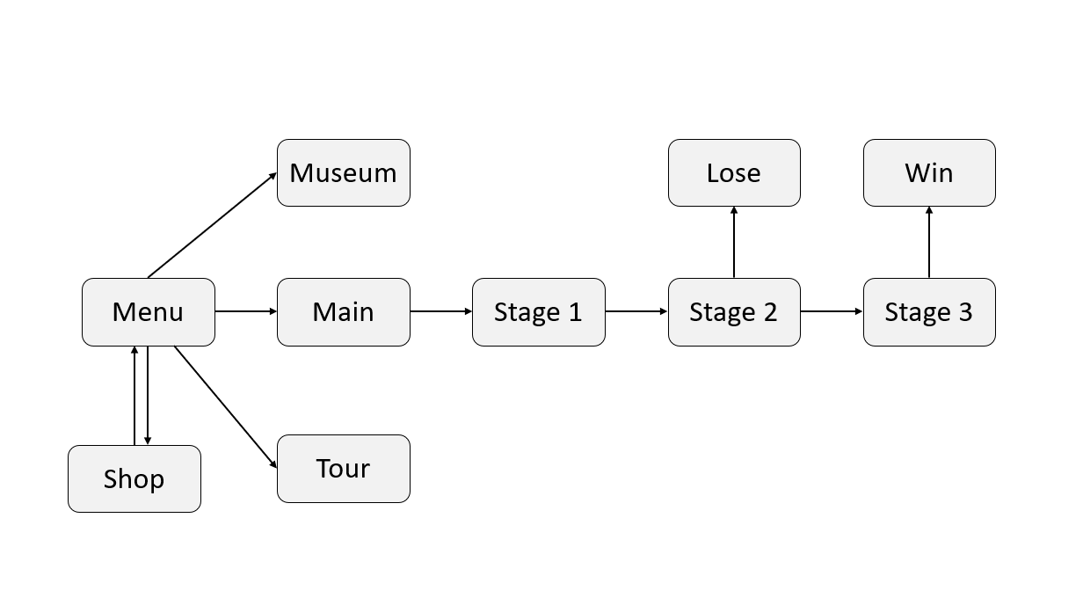

The game starts at the main menu. From there the shop menu can be accessed. The from the menu the player can then select from the 3 modes, Museum, Tour, and the main game.

The tour mode is a guided mode in which the player is told about the Ebola virus and quizzed on the information they learned.

The museum mode is a free roam around the Museum map, which contains exhibits on the Ebolavirus.

The main Game has 3 stages. Stage 1 can only be completed to move to stage 2, in which running out the timer results in a loss, and completing the objective results in progression to stage 3, upon the completion of which will lead to a win.

# Development information

## Library

<https://www.bbc.com/news/health-48637688>

<https://www.sciencenews.org/article/year-review-science-faces-ebola-epidemic>

<https://www.researchgate.net/figure/Ebola-affected-countries-on-the-world-map-The-coloured-area-depicts-Ebola-presence-from_fig4_310797842>

<https://blog.cafod.org.uk/ebola-poster/>

<https://ngonisafarisuganda.com/2022/10/06/statement-on-ebola-virus-disease-in-uganda/?utm_source=rss&utm_medium=rss&utm_campaign=statement-on-ebola-virus-disease-in-uganda&utm_source=rss&utm_medium=rss&utm_campaign=statement-on-ebola-virus-disease-in-uganda>

<https://www.expat.or.id/medical/ebola.html>

<https://www.stabroeknews.com/2019/07/27/news/guyana/ministry-sounds-alert-over-ebola-virus/><https://microbiologyinfo.com/wp-content/uploads/2014/11/Symptoms_of_ebola.png>

<https://www.facebook.com/WHOAFRO/photos/what-are-the-typical-signs-and-symptoms-of-ebola-virus-infectionebola-symptoms-v/850965271775057/>

[https://www.google.com/url?sa=i&url=https%3A%2F%2Fwww.researchgate.net%2Ffigure%2FTimeline-of-West-Africa-Ebola-virus-disease-outbreak-2014_fig1_266683640&psig=AOvVaw21yBpk87fRYC87ODBdsROs&ust=1672972584917000&source=images&cd=vfe&ved=0CA0QjRxqFwoTCPifhdiyr_wCFQAAAAAdAAAAABAD](https://www.researchgate.net/figure/Timeline-of-West-Africa-Ebola-virus-disease-outbreak-2014_fig1_266683640)

## Version of software

Blender 3.4

Blender 3.3.1

Blender 2.8

Adobe Illustrator 2022 v27.0

## Hardware requirement

Desktops to code, make and run the game

## Setup of development platform

Download Roblox Studio through Roblox website.

Create or join a build that you are part of and add others by their user name

## 

APPENDIX: Code base location

Talking:

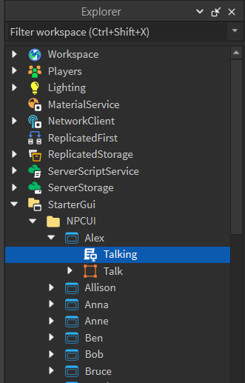

Emote:

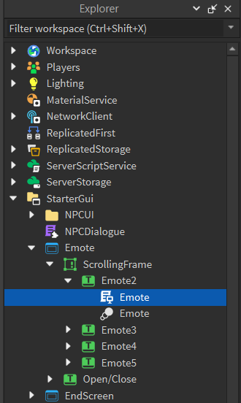

MenuScript:

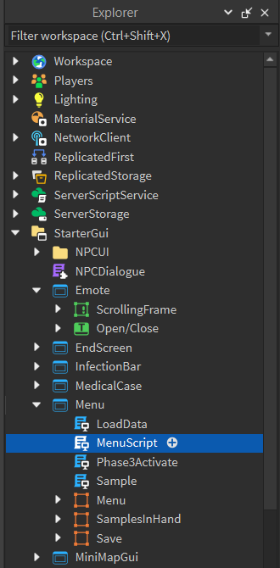

Sample:

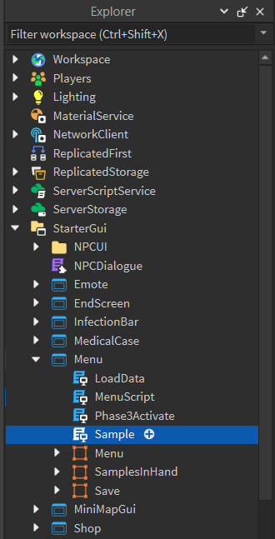

CarShop:

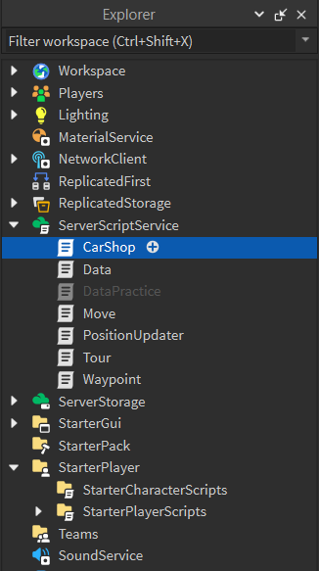

Phase3Activate:

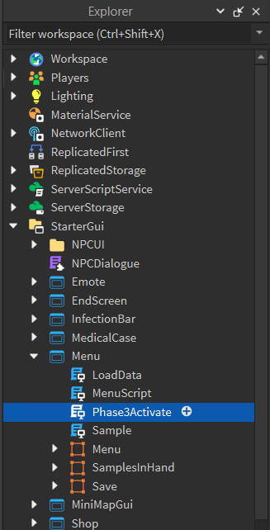

Car Script:

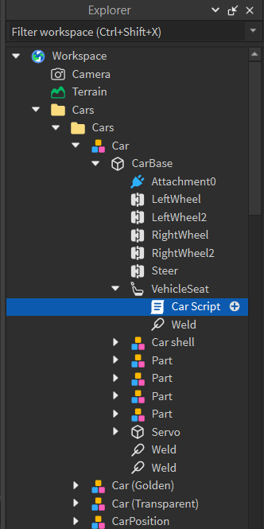

Waypoint:

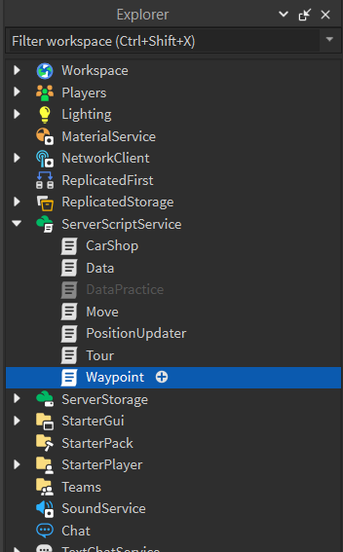

LoadData:

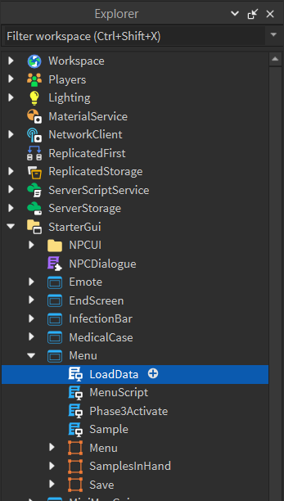

Data:

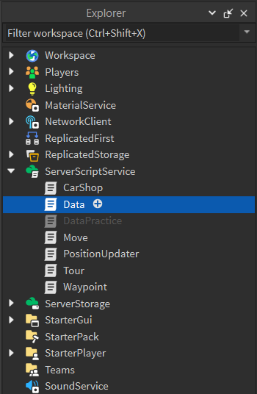

Car:

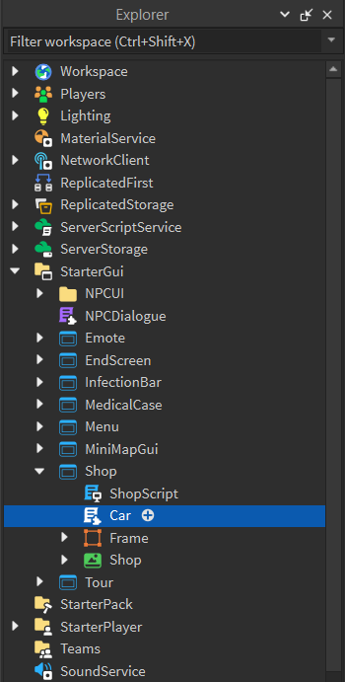

ShopScript:

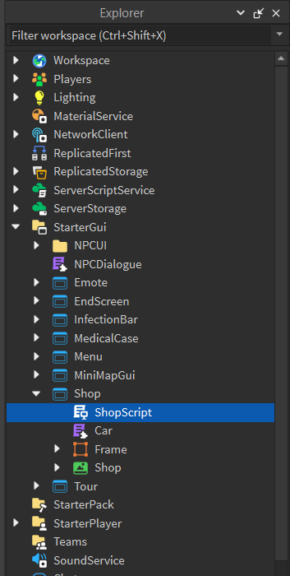

Tour:

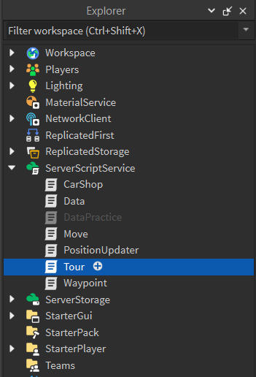

Infection:

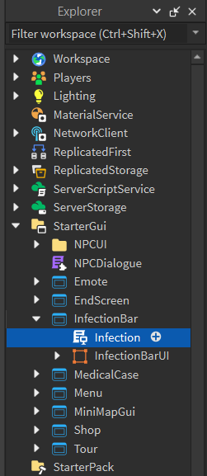

MedicalKit:

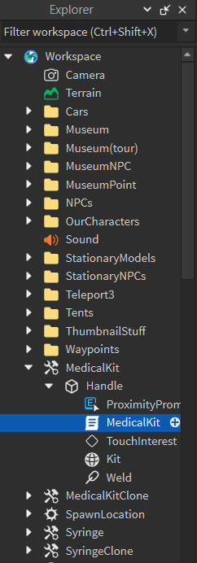

Syringe:

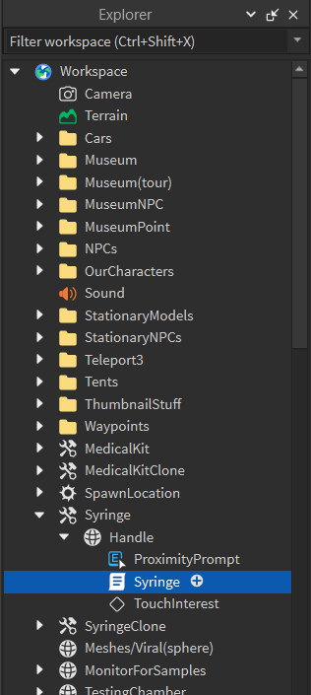

TourGuide:

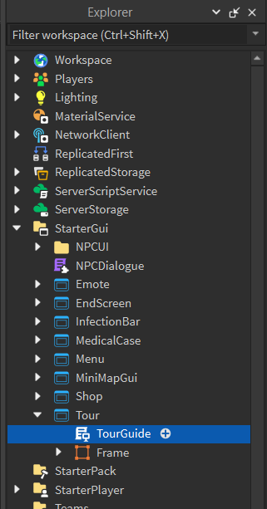

InfectionMaster::

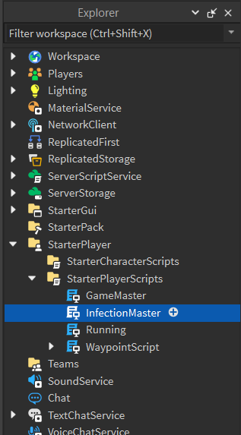

GameMaster:

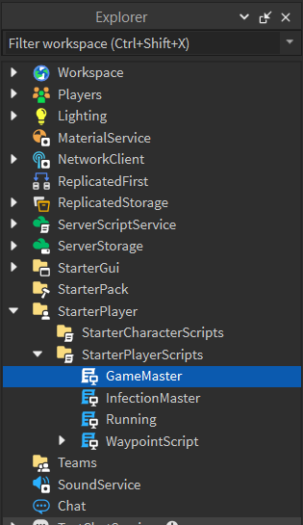

Running:

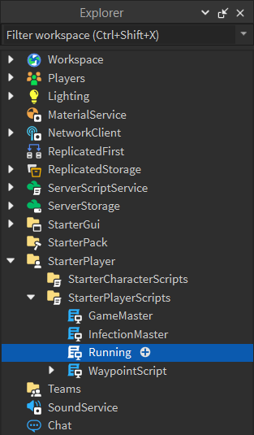

WaypointScript

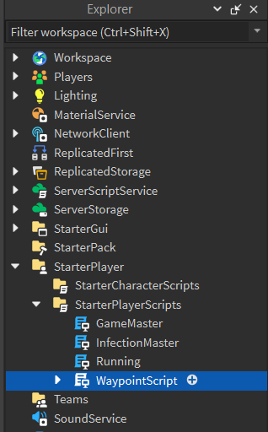

EndScreenSetter:

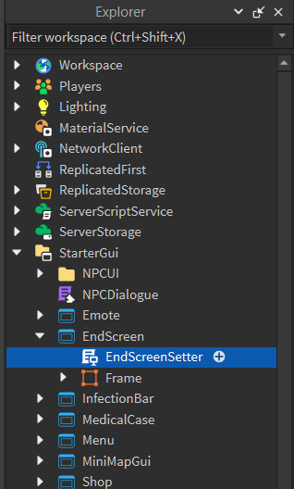

Move:

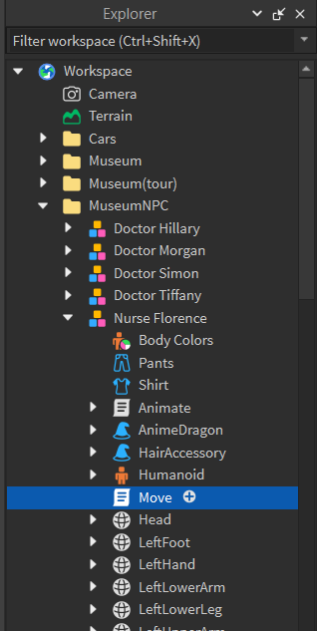

Render:

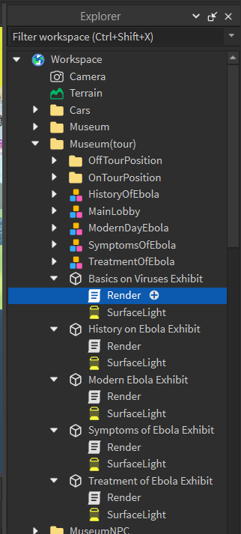

MedicalCase:

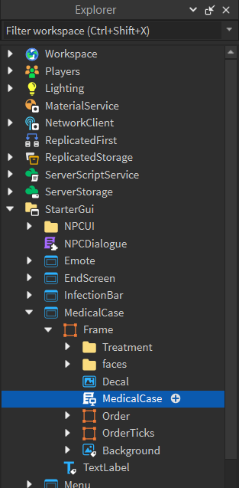

CavePrompt:

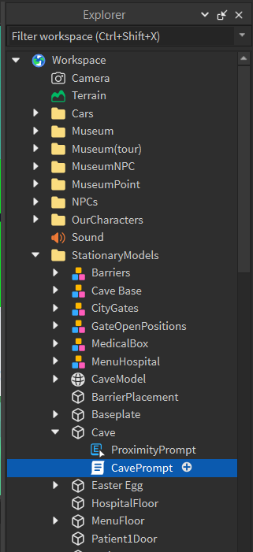

ColorChanger:

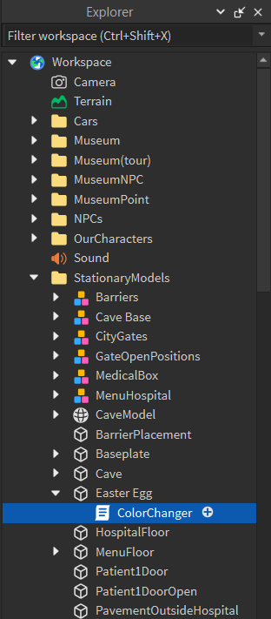

Teleporter:

